A Project/Dissertation Review-1 Report
on
Geolocation Location Analysis

Submitted in partial fulfillment of the
requirement for the award of the degree of

Bachler of Technology, School of Computer Science and Engineering



Under The Supervision of
Mr. Surrendra Singh Chauhan

Submitted By
Rohit Sahu 19021011417
Anubhav Soni, 19SCSE1010693

SCHOOL OF COMPUTING SCIENDE AND ENGINEERING DEPARTMENT OF COMPUTER SCIENCE AND ENGINEERING GALGOTIAS UNIVERSITY, GREATER NOIDA
INDIA
MONTH, YEAR


SCHOOL OF COMPUTING SCIENCE AND ENGINEERING
GALGOTIAS UNIVERSITY, GREATER NOIDA

CANDIDATE’S DECLARATION

I/We hereby certify that the work which is being presented in the thesis/project/dissertation, entitled “Geolocation analysis for suitable ” in partial fulfillment of the requirements for the award of the ______________submitted in the School of Computing Science and Engineering of Galgotias University, Greater Noida, is an original work carried out during the period of month, Year to Month and Year, under the supervision of Mr. Surrendra Singh Chauhan, Assistant Professor, Department of Computer Science and Engineering, Galgotias University, Greater Noida
The matter presented in the thesis/project/dissertation has not been submitted by me/us for the award of any other degree of this or any other places.
Rohit Sahu, 19SCSE1010228
Anubhav Soni, 19SCSE1010693
This is to certify that the above statement made by the candidates is correct to the best of my knowledge.
Mr. Surendra Singh Chauhan
Assistant Professor

CERTIFICATE
The Final Thesis/Project/ Dissertation Viva-Voce examination of Name: Admission No has been held on _________________ and his/her work is recommended for the award of

Signature of Examiner(s) Signature of Supervisor(s)

Signature of Project Coordinator Signature of Dean

Date:
Place: Greater Noida

Table of Contents
Title |  | PageNo.
List of Table |  | 3
List of Figures |  | 3
Abstract |  | 4
Chapter 1 | Introduction | 5
 | - 1 Introduction | 5
 | - 2 Formulation of Problem | 5
 | 1.2.1 Tool and Technology Used | 5
 | 1.3 The steps involed | 6
Chapter 2 | Literature Survey/Project Design | 7
Chapter 3 | Functionality/Working of Project | 8
Chapter 4 | Results and Discussion | 11
Chapter 5 |  | 12
  Conclusion and Future Scope
  5.1 | Conclusion
  5.2 | Future Scope
  Reference
Chapter 5 |  | 12
Chapter 5 |  | 12
Chapter 5 |  | 13

student Information
Name | Admission Number | Enrolment Number | Program/Branch | Section/Batch
Rohit Sahu | 19SCSE1010228 | 19021011417 | B.Tech/SCSE | 03/p2
Anubhav Soni | 19SCSE1010693 | 19021011841 | B.Tech/SCSE | 03/p1  ‘

Faculty Information
Name | Designation | Role
Mr. Surendra Singh Chauhan | Assistant Professor | Guide
Mr. Vivek Anand M | Assistant Professor | Reviewer

Table of figures
Figure No. | Figure | Figure Nam
 | Data Flow Diagram | Steps
 | Data Visualization | Data Visualization
 | Elbow method | Elbow Method, for optimal k value
 | K-means visualization | The clusters in the data
 | Result | Result

Acronyms
PG | Paying Guest
B.Tech | Bachler of Technology
API | Application Programming Interface
SCSE | School of Computer Science and Engineering
REST | Representational State Transfer

Abstract
It happens too often that one has to travel to another unknown city, for work, education, or tourism, so it becomes that one finds place to accommodate, now if you are going on a vacation then it is short term stay, you can just book a hotel and do the side seeing. For student, immigrant or worker. They want affordable place to stay.

This project tries to find the best possible location according to some predetermined parameters which are set and trained according to the data collected from such type of people, and Geolocation of a particular location can be used, then the data will be fed to the K-Means Clustering algorithm, whose result will then be represented on a Map, using REST API.

For this purpose the Machine Learning algorithm, K-Means Clustering, will be used to find the locations or cluster of locations. Initially data will be read, using Python’s Pandas library, and this data will be cleaned using Pandas as well, then the data will be visualized using matplotlib library or pandas, to gain insights from the cleaned data. For presenting the Geolocation data REST API will be used.

The final result will be presented on a Map using REST API, which will make it much easier to locate the desired location or get the approximate idea to the final location. This analysis will greatly narrow down the search for the place to stay

Lastly it is to be expected that the data will be needed to do the such analysis, and the result are profitable for the businesses, Like Apartments, Hostels, or Paying Guest Houses. Small business owner can use this data to find the ideal location for their new venture.

KEY WORD: Machine Learning, suitable accommodation.

Chapter-1: Introduction
  - This project tries to look into the problem and hassle of finding a suitable place to stay for immigrant, Job seekers or student. And it does so using collected data of preferences and taste of individual and Geolocation data to show where is that ideal place.

  - It is not a uncommon that a certain individual need to travel from his/her home town to a town, where he has to be there in order to do some kind of work, they are migrating for better quality of life or their job takes them there.
Sometimes on short notice you have to travel, so there is very little time to plan, the traveller doesn’t have someone known in the said city then it becomes new experience to find a place on your own when you have to manage your job, or immigration process, any other thing that you have arrived to do.
Also, when business owner want to venture into some idea that involves choosing a location, then it is imperative to have appropriate information about the customer needs and location details.

1.2.1
K-means Clustering
K-means clustering (MacQueen, 1967) is a method commonly used to automatically partition a data set into k groups. It proceeds by selecting k initial cluster centers and then iteratively refining them as follows:
The algorithm converges when there is no further change in assignment of instances to clusters. In this work, we initialize the clusters using instances chosen at random from the data set. The data sets we used are composed solely of either numeric features or symbolic features. For numeric features, we use a Euclidean distance metric; for symbolic features, we compute the Hamming distance. The final issue is how to choose k.[1]

Python
Python is PROGRAMMING LANGUAGE that lets you work quickly and integrate systems more effectively.[3]

Pandas
pandas is a fast, powerful, flexible and easy to use open source data analysis and manipulation tool, built on top of the Python programming language. [4]

Matplotlib
Matplotlib is a comprehensive library for creating static, animated, and interactive visualizations in Python. Matplotlib makes easy things easy and hard things possible. [5]

Seaborn
Seaborn is a Python data visualization library based on matplotlib. It provides a high-level interface for drawing attractive and informative statistical graphics. [6]
Folium
Folium is a python Library that that builds on the data wrangling strengths of the Python ecosystem and the mapping strengths of the leaflet.js library. Manipulation of data is done in python, then visualize it in on a leaflet map via folium. [7]

- 3. The Whole Process at a glance.
The steps that involved are:
- Data collection, [8]
- Data cleaning,
- Visualizing the data,
- Applying the algorithm,
- Get geolocation data from foursquare API,
- Presenting the results on the folium library.
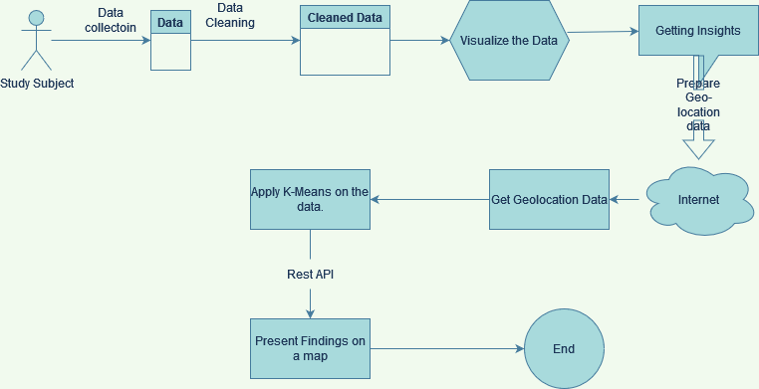
FIG: Steps

Chapter-2: Literature Survey

When one has to find a place to live in (not your hometown), the easiest way is to ask a group of people and they maybe will tell you the place you desire or somewhat match your description of your ideal place, but people usually tell from their experience which is based on their likes and dislikes.

Sometimes what happens is that, if they don’t know what you are asking then they will ask someone else, and then they will repeat their experience or if they will ask somebody, then that somebody might repeat the same thing.

This process is often time consuming might not meet your requirements. We also want to look at this problem at the business point of view, the revenue of a business depends on how many people are using their product or their service, and if they want to maximize their profit then they want as many people buy their product as much possible.

So, it would make sense that would want in on the information that t

This research is useful to businesses and working individuals alike. As this analysis give knowledge about where is the density of working individual, the business owner can decide where to move or open their business, this could lead to hike in profit margin, and overall positive growth.

Individuals can find a place to stay in unknown city or in their own city if they want to move somewhere within the city. This project can be scaled from localities, to cities to country.
Chapter 3: Explaining the process
- Data collection
The data is obtained from Kagle[8]
The geolocation data is obtained from the Foursquare API, the location data is obtained around Galgotias University, within a radius of 30 km, as the University is remote and there are very few places to stay, within 10 km , that suit the budget of your normal student.

Then data is loaded using the pandas library.

- Data cleaning
Initially the data contains about 60 features, most of them are irrelevant and some are not numerical so they need to be removed.
The features that stay are, ['cook', 'eating_out', 'employment', 'ethnic_foo'
, 'exercise', 'fruit_day', 'income', 'on_off_campus', 'parents_cook',
'paymeal_out', 'sports', 'veggies_day']
Total features = 12
These features have multiple or two options that are number from 1(least likely) to 6(most likely)
According to the question answer change.

- Visualize the data
The cleansed data is then plotted, using box plot
This how the data looks
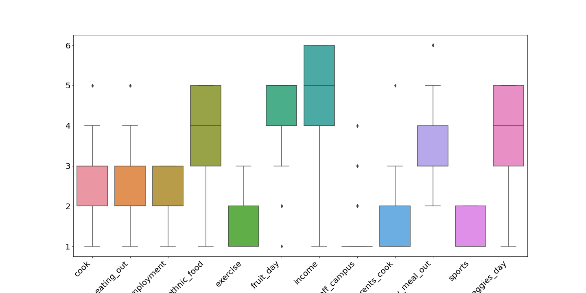
Fig: Data Visualization
- Apply k-means clustering on the user data and get insights
A intrinsic step for any unsupervised algorithm is to determine the optimal number of clusters into which the given data is or may be clustered.[12]
To the do exactly this there is a method called ‘The Elbow Method’[11]. This method is very popular to determine the optimal number of clusters, that the data may be clustered in .

This method uses the SSE or Sum of Squared Distance between the data points and their respective assigned clusters centroid or says mean value. And we pick k value at where the point SSE starts to flatten out and forming an elbow.[10]

This is how the method helps to find the good value of k (number of clusters for the dataset) and help in making the good clusters for the given dataset.
The data set for run on 1 to 20 clusters and using the Kmeans algorithm and then the result of those cluster was plotted on a graph. This result look like this:
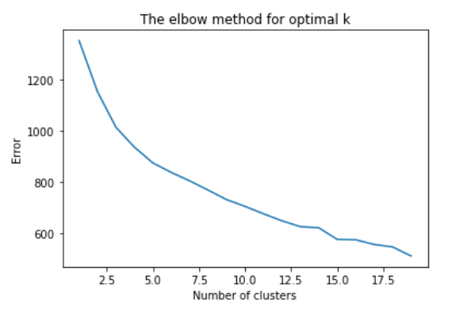
Fig: Elbow Method, for optimal k value
The optimal value chosen for the algorithm to apply to is 3. We noticed that when the clusters were increased or decreased then the result were not very useful so we had to choose 3, as the number of clusters.

Then we will apply the actual algorithm to the data and plot the clusters using matplotlib and find some trend.
K-Means clustering is applied with three clusters, this is how they look.
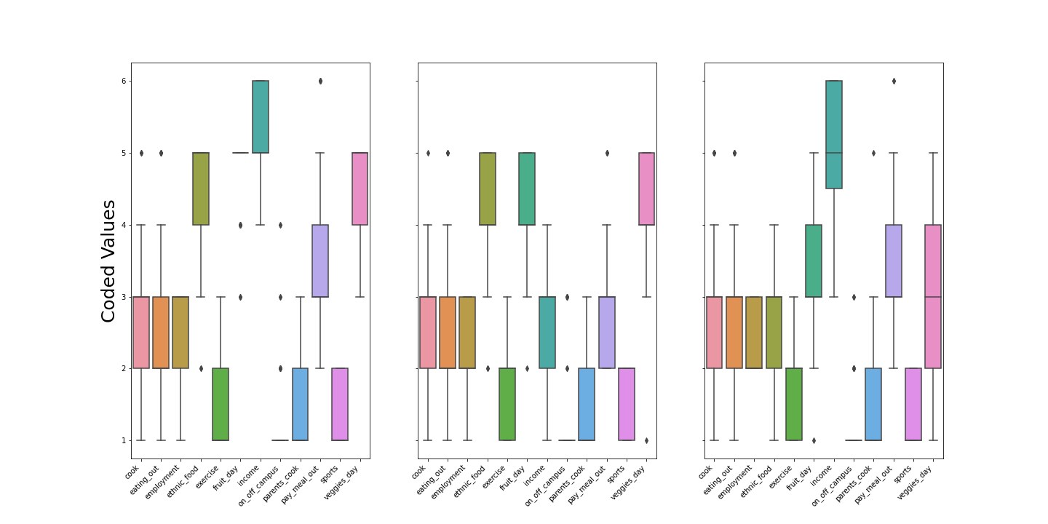
Fig: The clusters in the data

There are some points that can be noticed,
As the income increases
People with high income:
- Prefer fruit day
- Prefer to go out and eat at a restaurant sometimes.

People with low income:
- Prefer to stay home and cook
- Rarely want to go out and eat.
- Want to have vegetable shops around them.

- Get geolocation data from Foursquare API [5]
To get the venues data from foursquare API visit their website.
Register on the website and login.[5]
Find the Places and Pilgrim SDK and log in there.[5]
You will be taken to your projects page.
Make a new project there, and you will be given “Client id” and “Client Secret”, what will be used to, access the access the data.

- According to the insights present location data on folium

The result is divided according to the distance,
- blue marker is my college
- green are the location between 10 and 20 kilomter
- orange are the distance between 20 and 30 kilometer
- red are the distance between 30 to 35 km
- darkred are the distance greater than 35(not at all feasable and no location given)
- pink could have the distance below 10 kilometer but data could not show that, but there are two location slightly greater than 10(green).

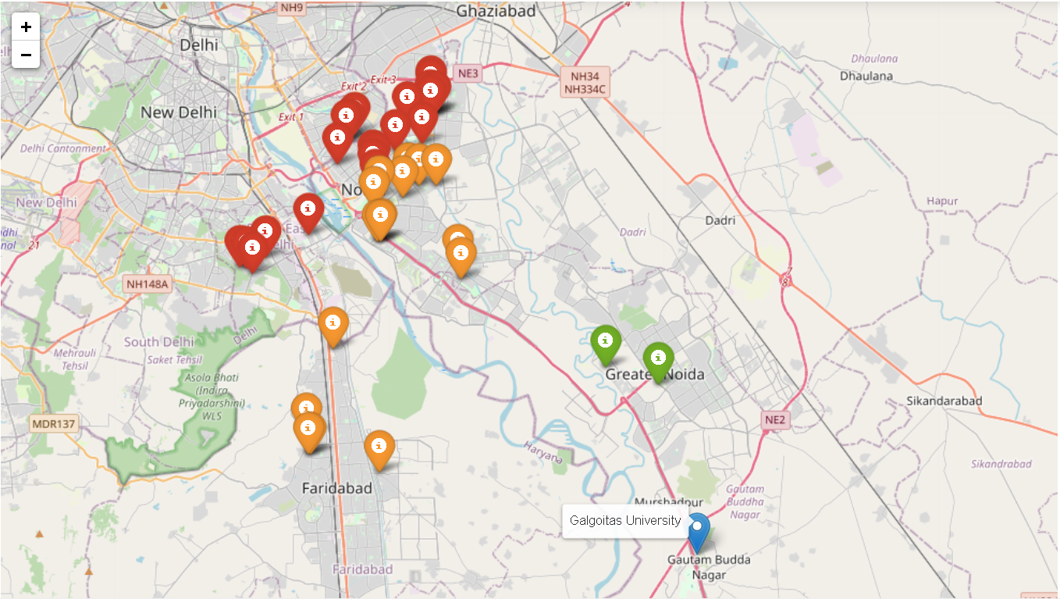

Fig: Result

Chapter 4: Result and Discussion
The data that we got around the GU, is not very good, as the location are spread far apart, and the nearest location found was roughly 10 kilo meters away.

There are location that are between 20 to 30 kilometer but there are not that many and as the distance increase the time that is taken to get to the university is also increased.

When the places such as restaurant and grocery market, were found out using the foursquare API around that location then the number was above 5 or 10 that is more than enough for a student or a Service worker, as there are more residential areas, then the services available also increase, the problem comes when there are less people, that usually means that the business owners would not want to move to that location and that are there then to hike the price of the commodities, in order to earn more thus make more profit.
Chapter 5: Conclusion and Future Scope
- 1 Conclusion

- There were no location around University, within 10 KM, and only two locations between 10 and 11 KM, that too are apartments.
- The location data around Galgotias University is not very good, thus there might be some locations that didn't reflect in the above map
- Students can look for apartments around, 'Knowledge Park' Area.
- For better analysis need more data around the locations.
- As we cross the 20 KM mark we start to see some PGs and more apartments, there are pgs around Amity university
- You would need a transport facility to drop and pick you up from the univeristy.
- PGs are more clustered around Noida, but they are at a distance of more than 25 KM
- There is one more university around Galgotias University, so business owners should think about building something there, that accomodates the students there.
- The location each have at least 2 restaurants, 2 grocery stores and 2 markets
- It would be better to choose according to income, the distance from university is a major factor.

5. 1 Future Scope
This analysis can be used by business owner to build infrastructure around the discussed location, it will going to be profitable as so many students are finding a place to stay.
This project can be scaled to cities and states to get more analysis around the habits of how people choose a place to stay, and the government act accordingly in-order to build more infrastructure.

Reference:
- https://web.cse.msu.edu/~cse802/notes/ConstrainedKmeans.pdf
- https://www.educba.com/k-means-clustering-algorithm/
- https://www.python.org/
- https://pandas.pydata.org/
- https://matplotlib.org/
- https://seaborn.pydata.org/
- https://python-visualization.github.io/folium/
- https://www.kaggle.com/borapajo/food-choices
- https://foursquare.com/log-in/
- https://www.datadriveninvestor.com/2020/01/21/elbow-method-metric-which-helps-in-deciding-the-value-of-k-in-k-means-clustering-algorithm/
- https://www.geeksforgeeks.org/elbow-method-for-optimal-value-of-k-in-kmeans/
- https://medium.com/mlearning-ai/k-means-clustering-using-elbow-method-208b23c78150

